Service Area 2 Healthcare Coalition

Information Sharing

Annex _____

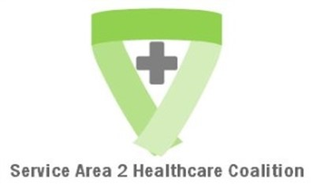

Revisions Dates: Initial Draft Plan

Region 2 Healthcare Preparedness Coalition
Information Sharing Annex

Introduction/Goal
The Coalition Information Sharing annex is designed to address protocols for coordinating the sharing of information during planning and response. This Information Sharing annex addresses the process for initiating and sustaining interoperable communications between Region 2 Healthcare Preparedness Coalition (hereafter referred to as Coalition) members (Healthcare, EMS, Public Health and Emergency Management) along with other stakeholders.
Purpose
Information sharing will be conducted through multiagency coordination which supports efficient and timely situational awareness for Coalition members. Multiagency coordination is a process that allows all levels of government and all disciplines to work together more efficiently and effectively. Multiagency coordination occurs across the different disciplines involved in incident management, across jurisdictional lines, or across levels of government. Multiagency coordination can and does occur on a regular basis whenever personnel from different agencies interact in such activities as preparedness, prevention, response, recovery, and mitigation. The purpose of multiagency coordination for a health related event or incident is to:
- Support incident management policies and priorities through stakeholder engagement
- Provide discipline-specific information to support a common operating picture that is regionally coordinated
- Facilitate health and medical resource sharing
- Facilitate resource-tracking and victim tracking for family reunification

Scope
The scope of this annex is information shared between the Coalition member disciplines and other relevant stakeholders, as determined at the time of an incident or event. It includes what information is shared, how it is shared, and with whom and why it is shared. This information sharing annex does not supersede any local plans or processes.
Planning Assumptions
- Each agency that is a member of the Coalition has a process to share information within their agency/organization
- Each agency identifies and shares key questions and data elements necessary for local decision making to support Coalition members in an incident or event
- Each of the primary disciplines of the Coalition have an information sharing process to coordinate information within their discipline
- The information gathered within each of the primary disciplines will be shared through Coalition information sharing process
- The Coalition Information Sharing process provides multiagency coordination beyond each disciplines’ information sharing process
- Each of the primary disciplines’ coalition members will share the information gathered from multiagency back to their discipline through their communications process

Flow of Communication
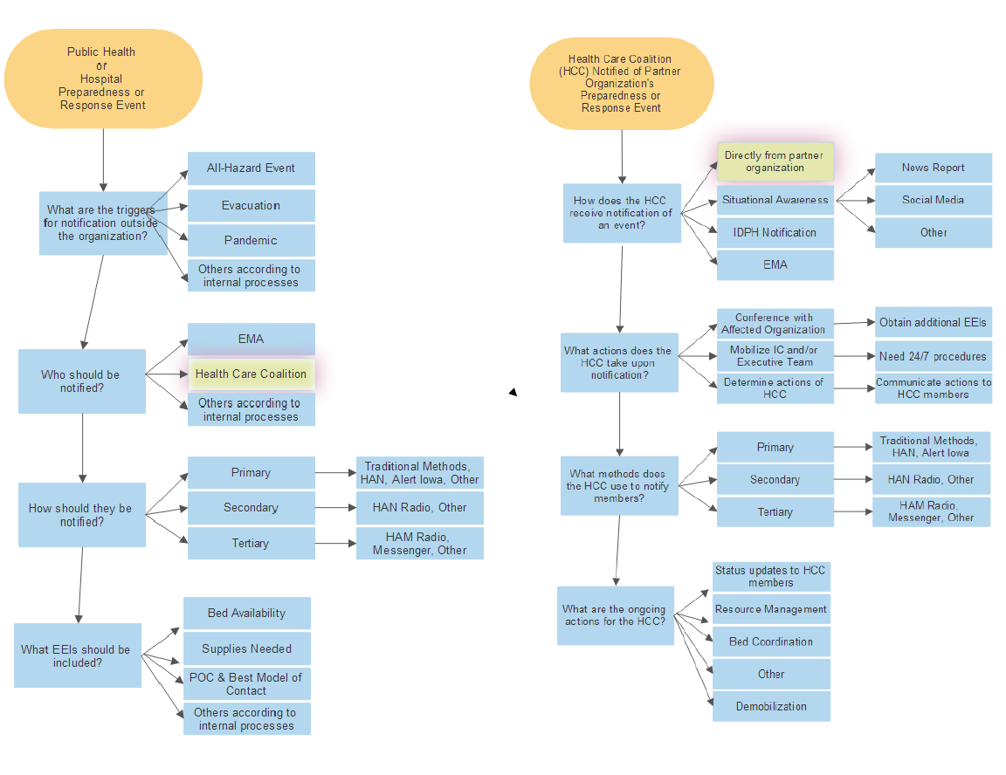

Regional Activation
Regional activation is accomplished if requested by any of the core members of the Region 2 Healthcare Preparedness Coalition through email or phone call to the Region 2 Grant Coordinator(s) to activate the Response Plan (as reflected in the diagram above, based on triggers identified by each core member).

